## Create and attach disk to instance

1. Go to Instance page from hamburger menu and scroll down to storage, select disk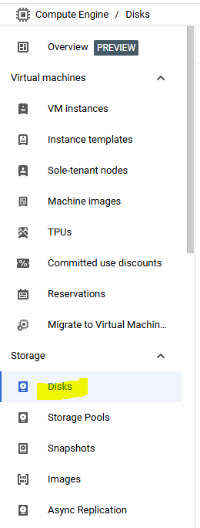
2. Click create disk

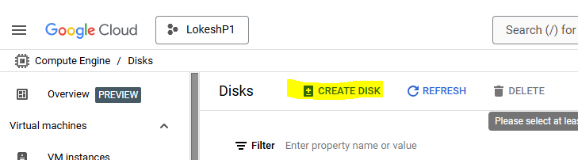

1. Give disk a name
2. Select zone and regions, make sure to select it same as the VM you want to attach with

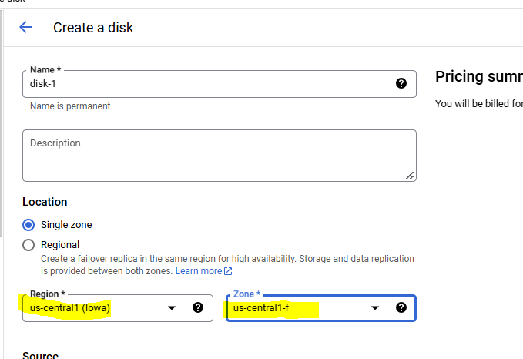

1. Select disk type and required size

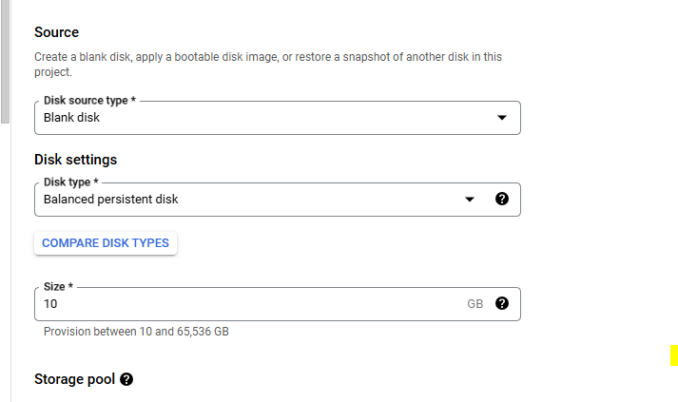

1. Click create at the bottom
2. Go back to vm instance page and click on name of the instance where want to connect disk

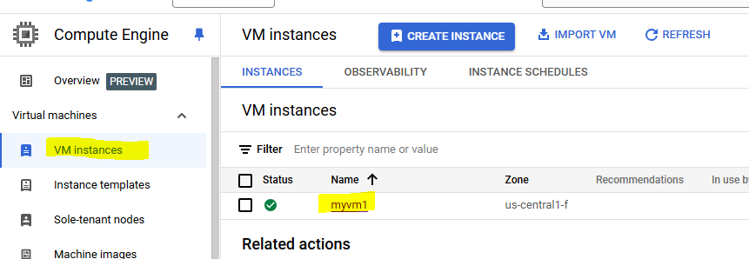

1. First connect to VM and run lsblk command to see attached disks, it will show only boot volume

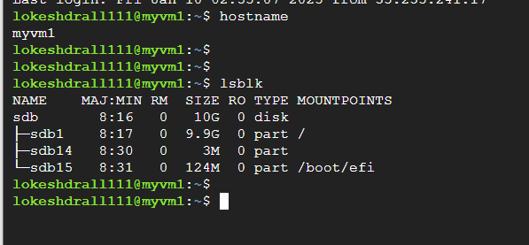

1. Now click edit

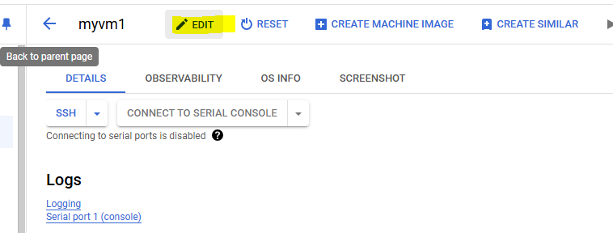

1. Scroll down and click attach existing disk

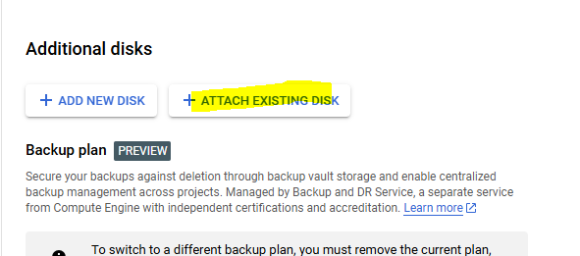

1. Select the newly created disk, keep it read/write and click save

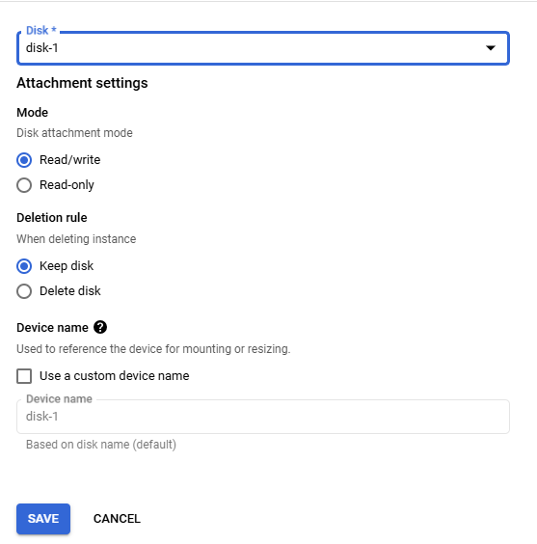

1. Click save button at the bottom of the page

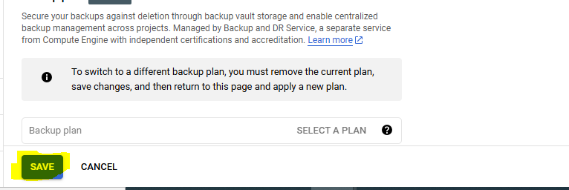

1. Now should be able to view that attached disk under local disks

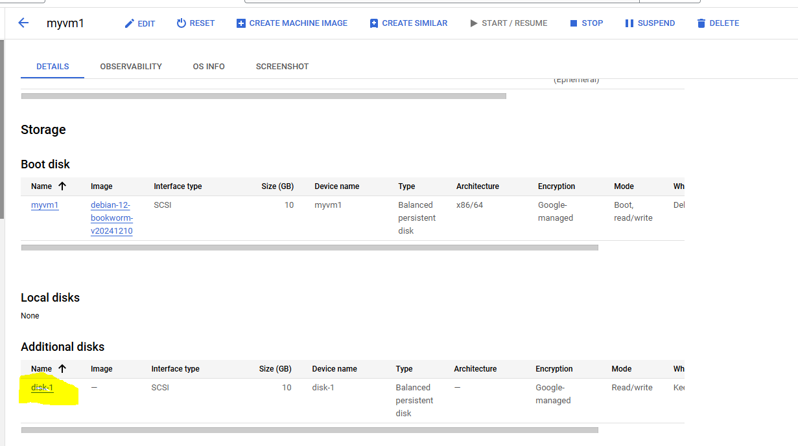

1. Now if run lsblk again to vm, it will show additional disk as well

